Erick Maiko Akama
Response to the Assignment Tasks
- I have utilized STATA version 14
- Data loading and inspection (please refer to the shared dofile)

- Descriptive Statistics

On average, the age of the household head (age 1) was approximately 49 years (48.67) with a high standard deviation of about 13.6 years (implying heterogeneity) in the age of the household across the countries under study. However, the minimum age of 1 year for the household implies that either data entry was improperly done and therefore requires cleaning. The oldest household head was about 100 years old. About 3.8% of the household head were male while about 97% were female

Variable | Obs | Mean | Std. Dev. | Min | Max
gender | 8800 | .038 | .191 | 0 | 1
age1 | 9448 | 48.665 | 13.613 | 1 | 100
age2 | 9233 | 36.59 | 14.047 | 0 | 115
age3 | 8980 | 22.824 | 13.021 | 0 | 100
age4 | 8545 | 18.928 | 12.022 | 0 | 134
age5 | 7783 | 16.052 | 11.54 | 0 | 90
age6 | 6781 | 13.739 | 11.846 | 0 | 121
age7 | 5704 | 11.964 | 11.894 | 0 | 99
age8 | 4764 | 10.28 | 11.804 | 0 | 100
married1 | 8797 | 1.198 | .657 | 1 | 20
married2 | 8594 | 1.378 | 1.009 | 0 | 7
married3 | 8366 | 2.41 | 1.512 | 0 | 7
married4 | 8001 | 2.775 | 1.612 | 0 | 9
married5 | 7354 | 3.019 | 1.644 | 0 | 12
married6 | 6511 | 3.098 | 1.74 | 0 | 17
married7 | 5609 | 3.086 | 1.836 | 0 | 7
married8 | 4804 | 3.058 | 1.912 | 0 | 11
hhsize | 9463 | 7.277 | 4.555 | 1 | 200
educ1 | 8585 | 5.248 | 5.246 | 0 | 35
educ2 | 8363 | 4.194 | 4.877 | 0 | 31
educ3 | 8128 | 5.324 | 5.05 | 0 | 21
educ4 | 7740 | 5.022 | 4.806 | 0 | 20
educ5 | 6762 | 4.487 | 4.569 | 0 | 24
educ6 | 5799 | 3.666 | 4.424 | 0 | 84
educ7 | 4715 | 3.048 | 4.063 | 0 | 20
educ8 | 3816 | 2.437 | 3.999 | 0 | 84

- Data Cleaning & Transformation
Some of the key inconsistence in this data set include
- Both farmsalev and farmbuyv which specifically captures sale and purchase value of farm including buildings have unclear units
- The gender variable that ranges from (gender1-gender8) have missing variables
- The age variables that ranges from (age1- age8) equally has missing variables
- In some cases missing data is indicated by different labeling such as “-99”, “-999”, “.”,” “
- The fplots variable Should be between 1 and 4, 4 for more than 3 plots but other numbers were reported as well in all countries except for Burkina Faso and Zimbabwe
- According to the questionnaire, fsystem1, fsystem2 (which is the variables that captures farming system on largest plot and on second largest plot) are supposed to be between 1 and 5 but can be 6 in Ethiopia, Egypt, South Africa, Zambia
- Probability & Mathematical Modelling
Due to time constraining, I have only used farmwork1 and nfarmwork1 to compute the probability and the model the expected number of households meeting the criterion in a sample of 100 randomly selected households
The answer is about 36 households (36.23)
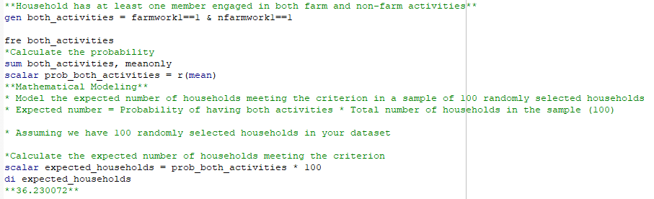
- Data visualization
